Ultimate Guide to the Presidents: “Changing of the Guard” - 1920-1945
Video Supplement
Warren Harding
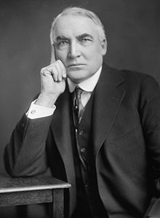
Warren G. Harding was the ________________ president of the United States. He followed Woodrow Wilson and served from _______________ until his untimely death in _________________. Pledging a nostalgic “return to normalcy” following World War I, Harding won the presidency by the greatest popular vote margin to that time. He died at the age of ___________during his third year in office.
“America's present need is not heroics but healing; not nostrums but normalcy; not revolution but restoration.”

(00:00-9:08 ) Viewing Guide Questions
- In the presidential election of 1920, what were women allowed to do for the first time?

- In the election of 1920, why were the American people crying for change?

- There were many factors that led to the election of Warren Harding. Name at least two.

- According to the video, Harding was a terrible president. What made him so bad?

- Harding had a few major scandals. All of these scandals have the same basic cause. What was the cause of the scandals?

- Harding is the first US President to visit which state?

Additional Information
- The Budget and Accounting Act of 1921 which required the president to submit an annual budget. The act also gave the executive branch control over federal spending for the first time.

- In 1921–22 the United States hosted the Washington Naval Disarmament Conference. Under the leadership of Secretary Hughes, the conference succeeded in getting the world’s major powers to agree to halt the arms race in production of large naval vessels

Calvin Coolidge
Calvin Coolidge was the ________________ president of the United States. He served as vice-president under Warren Harding and was sworn in as POTUS upon Harding’s death. Coolidge served as president from ______________ to __________________. He restored integrity to the office after the scandals of his predecessor Harding had brought shame to the presidency. Coolidge was nicknamed “Silent Cal” because he had a reputation of being a man of a few but well-chosen words.
“You can’t know too much, but you can say too much.”

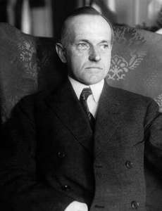

(9:08 – 16:55 ) Viewing Guide Questions
- Coolidge was left cleaning up after the scandals of Harding’s administration. What did he do to restore the dignity of the presidency?

- For what personality trait was Coolidge known?

- The `20s was an especially prosperous time. According to the video, what led to this prosperous state?

- What technology helped Coolidge express his ideas to the American people?

- Coolidge decides not to seek re-election, what reason do most people give for his decision?

Additional Information
Reflecting its focus on internal economic growth, the Coolidge administration showed little interest in events outside the nation’s borders. Coolidge adamantly opposed U.S. membership in the League of Nations, though he did increase unofficial American involvement in the international organization. Ironically for such an inward-looking administration, two of its members received the Nobel Prize for Peace. In 1925, Vice President Charles G. Dawes won the prize for his program to help Germany meet its war debt obligations, and Secretary of State Frank B. Kellogg won it in 1929 for his role in negotiating the Kellogg-Briand Pact, a multinational agreement renouncing war as an instrument of national policy.

Herbert Hoover
Herbert Hoover was the ________________ president of the United States. He served as president from ______________ to _____________. Hoover served as secretary of commerce under _____________________________ and _____________________________. His presidency was most notably marked by the stock market crash of 1929 and the beginnings of the Great Depression. Hoover’s inability to help America during the Great Depression turned his name into a synonym for _____________________.

“My country owes me nothing. It gave me, as it gives every boy and girl, a chance. It gave me schooling, independence of action, opportunity for service and honor.”

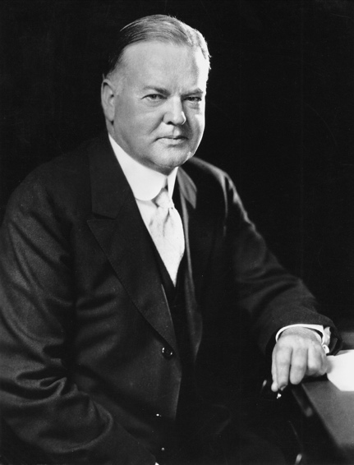
(16:55 – 21:32 ) Viewing Guide Questions
- Herbert Hoover had a different background from most other presidents. What was Hoover’s background?

- Herbert Hoover had been successful in preventing ________________________________ in Europe following WWI.

- Historian H.W. Brands said, “If he’d been elected in 1920, Herbert Hoover would have been a great president...It was his misfortune to be the right man at the wrong time.” What did Brands mean by this?

- What happened on October 29, 1929, just 7 months after Hoover took office?

- Why wouldn’t Hoover help the desperate American people during the Depression?

- How did Depression-era American view Hoover?

Additional Information
- President Warren G. Harding picked Hoover to be his secretary of commerce, as did President Calvin Coolidge after him. In this role, he was the driving force behind such projects as the St. Lawrence Seaway and the Hoover Dam.
- Hoover opposed American entry into World War II (until Pearl Harbor was attacked) and condemned American involvement in the Korean and Vietnam wars.
- He was the author of several books and was working on another book when he died in New York City in 1964, at age 90.

Franklin D Roosevelt
Franklin Delano Roosevelt was the ________________ president of the United States. He served as president from ______________ to _____________. FDR is the only president elected to the office ________________________. He is remembered for leading the United States through two of the greatest crises of the 20th century: the ___________________________________________ and _______________________________________.
“When you reach the end of your rope, tie a knot in it and hang on.”

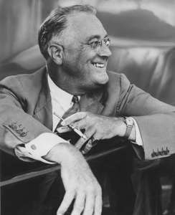
( 21:32 – 30:44 ) Viewing Guide Questions (watch until the start of WWII)
- How did Roosevelt’s inaugural address help the nation?

- Roosevelt’s first step was to shut down and restructure the banks. Most notably, he started insuring the banks. When they reopened, what happened?

- How did Roosevelt control his public image?

- What were the “fireside chats”?

- In spite of all of FDR’s New Deal programs, what was the economy of the 1930s like?

Additional Information
During his lifetime Franklin D. Roosevelt was simultaneously one of the most loved and most hated men in American history. His supporters hailed him as the savior of his nation during the Great Depression and the defender of democracy during World War II. Opponents criticized him for undermining American free-market capitalism, for unconstitutionally expanding the powers of the federal government, and for transforming the nation into a welfare state. It is generally accepted by all, however, that he was a brilliant politician.
- We will continue to study FDR in the next chapter – WWII

